Mid term review

**Monday**

- connection of computer network: IP internet protocol

- layers of communication: IP -> TCP/UDP -> HTTP/FTP/POP

- www is collections of websites and pages

- internet is larger: email, chat, online games

- www: tim berners lee

- each device has 32-bit IP (0-255)

- 2 types: static and dynamic

- IPv6 has 128-bit

- TCP: guarantee message top of IP

+ 80: web, 443 https

+ 25: email

+ 22: ssh

+ 21: FTP

- UDP: game, streaming

- web server: Apache, IIS

- DNS: mapping name to IP

- URL: identifier fro the location of web

- HEAD: information about the file, not the file'content

- 200: 0k

- 301-303: redirect

- 403: forbidden

- header: describe the page

- DOCTYPE: html version

- meta tag: name, content

- relative: ../../

- absolute

- **block-level elemetns**: always start on the new line: <div>, <p>,<h1>,<form>, <hr />

- **inline element**: not start on a new line and only takes up as much width as neccessary: <span><image><a>

- <img>: src, alt

- phrase elements: <em> (italic) <strong>

- comment: <!-- -->

- unordered list: <ul> <li>

- ordered list: <ol> <li>

- definition list: <dl> <dt> <dd>

<dl>

<dt>title</dt>

<dd>description</dd>

</dl>

- inline quote: <q>: can apply css to quotation

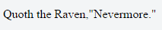

- blockquote: <blockquote> <-- is block

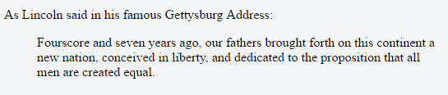

- computer code: <code> <-- inline

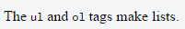

- Preformatted text: <pre> <-- **block**

- Abbreviations: <abbr>

<abbr title="description here">Text here</abbr>

- table: <table>

<caption></caption>

<tr>

<th></th> **(text will be bold)**

<th></th>

</tr>

<tr>

<td></td>

<td></td>

</tr>

</table>

- colspan: make the cell occupy multiple columns

- rowspan: multiple rows

**Tuesday: CSS**

- strong, em, u, font are discouraged in strict HTML

- HTML: for content

- CSS: presentation, how to display the page

- embedding style sheets, inline is bad practices

- comment: /**/

- font-family, font-size, font-style, font-weight, font (sets all font properties)

- pixels (px), point (pt) 1/72 inch, m-size(em) - 2em: 2 size of current font

- styles get inherited from containing elements

- not all properties are inherited: margin

- conflict -> later will apply

- the most specific one applies

- HTML(1) < CLASS(10) < ID(100)

**- CSS psuedo-classes: special state of an element: hover, move, click**

**- psuedo-element: specificed parts of an element:** ::first-line, ::first-letter, ::before, ::after (add content)

p::after {

content: " - Remember this";

}

- selector 1 selector2 {} <-- only if selector2 is inside 1

- selector 1 > selector2 {} <-- if selector2 is direct child

**Wesneday: Layout**

- CSS box

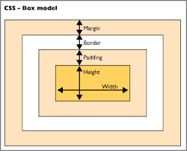

- width: content width + L/R padding + border + L/R margin

- border: 1px solid red; <- thich, style, color

- dimensions: for Block elements and img only

- box-sizing: content-box (width for content only) || border-box (border, padding, margin)

- centering a block elements: **auto margins, set width**

- inline boxes: ignore width, height, min-width, margin-top, margin-bottom (ingored), margin-left, margin-right (not ignored)

- vertical-align: vertically align inline element in block element

- float: must have width

- container too short -> past the bottom

- overflow

- column-count

- column-gap

- column-rule: 2px dotted gray

- block elements -> fixed, absolute -> its content

- use inline-block

- opacity: 0.5;

- reset browser css

HTML Forms: Connecting with the Source

- 3 ways send request to server: url, form, XHR

- GET: only has header

- POST: header, body

- <input> <textarea>, <button> <select> <option> <optgroup>, <fieldset><label>

- novalidate

- autocomplete

- input -> inline element, self-closed

- type: button, checkbox, file, hidden, password, radio, reset, submit, text,...

- value: initial text

- Radio button: group by name

- textarea: size by rows, cols

- dropdownlist with select: disable, multiple, size

- pattern work with: text, date, search, url, tel, email, password

**Serlets and web containers**

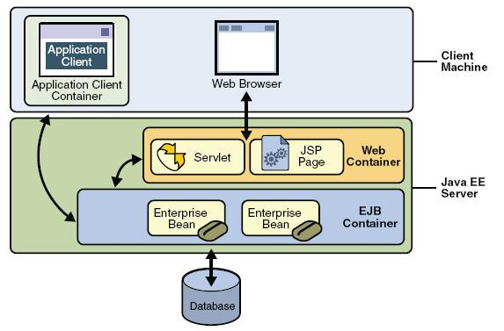

- A servlet is a Java class

- HTTP protocol is stateless

- POST: no limit data sent

- GET: limit